# Web Technology Personal Project Report

## **PERSONAL DETAILS**

**University**: University of Rwanda

**College**: College of Science and Technology

**Department**: Computer and Software Engineering

**Course Name**: Web Technology (COE2163)

**Student Name**: Derrick IRADUKUNDA

**Registration Number**: 221020634

**Year of Study**: Level 2

**Date**: 17/09/2022

Contents

Web Technology Personal Project Report 1

**PERSONAL DETAILS** 1

**1.** **INTRODUCTION** 3

**2.** **PROBLEM SPECIFICATION** 3

**2.1.** **Inefficient Proposed Government Solution** 4

**2.2.** **MyLostFind.Com The Succeding Platform** 5

**3.** **OBJECTIVES** 6

**3.1.** **GENERAL OBJECTIVES** 6

**3.2.** **SPECIFIC OBJECTIVES** 7

**4.** **FUNCTIONALITY** 8

**5.** **DESIGN** 8

**5.1.** **FLOWCHART** 8

**5.2.** **ERD** 8

**6.** **IMPLEMENTATION** 9

**6.1.** **Technologies used** 9

**6.2.** **better code** 9

**6.3.** **Responsiveness & Design** 11

**6.4.** **Homepage** 11

**6.5.** **About us Page** 14

**6.6.** **Guide & Faq Page** 14

**6.7.** **Report Lost Items Page** 16

**6.8.** **Submit Lost Items** 18

**6.9.** **Login And Creating Account** 20

**6.10.** **User Dasboard** 22

**6.11.** **Admin Dashboard** 28

**7.** **CONCLUSION** 33

**8.** **REFERENCES & OTHERS** 33

8.1. Git-Hub Link 33

8.2. Other Related Links and external sources 33

**8.3.** **Abbreviations** 34

## **INTRODUCTION**

In a world where the loss of important documents and personal items can lead to many hardships such as losing ownership of your land, risk of being un-identified because you lost your ID, the need for an efficient and user-friendly solution becomes evident. MyLostFind.Com is a Revolutionary project aimed at addressing this challenge head-on by providing a comprehensive platform that empowers individuals to recover their lost documents and items swiftly and hassle-free.

Our project offers a user-friendly platform where you can report lost items, and the community can help find and report them. It's about making the process easier, fast and more affordable, reducing the hassle of replacing lost items by endless bureaucracy of government organs and courts.

This document explores MyLostFind.Com, explaining its goals, how it works, and the benefits it brings to those who've lost something precious. Join us in creating a community where lost items find their way back home.

## **PROBLEM SPECIFICATION**

Losing important documents and items can create significant challenges for individuals in their daily lives. This issue is more than just an inconvenience; it can lead to financial burdens, emotional distress, and even hurdles in accessing essential services. Let's explore some real-life examples to understand the gravity of the problem:

* **OwnerShip Setbacks:** Losing the ownership papers of your assests may lead to your the loss of ownership of your asset or long bureaucracy in court. For example here in Rwanda as if you loose land ownership papers you go to court and debate to see if there is anyone who has ownership on that land, this can take months or even year and you are not allowed to use that land, meaning you are losing on that unused land.
* **Academic and Career Hurdles:** For students, losing important academic documents like transcripts can delay graduation and job applications. Employers often require proof of identity, which can be challenging without the necessary documents.
* **Healthcare Access:** Misplacing health insurance cards or medical records can hinder access to healthcare services, creating stressful situations when medical attention is urgently needed.
* **Emotional Loss:** Losing sentimental items, like family heirlooms or treasured photographs, can cause irreplaceable emotional distress.

### **Inefficient Proposed Government Solution**

**\*\*\***The Rwandan government has managed to tackle those problems through Irembo but they only Irembo carters to finding replacements to Identification cards and land papers. Irembo is not bad but it lacks some features in the document recovery process, The Irembo approach has the following Problems:

* **No Lost Submission Or Found Declaration:** The platform (irembo) Doesn’t have an option for users to submit found items or to declare lost item, it only provides application for replacements.
* **Fewer Documents:** The irembo lost Document application Replacement only works for Identification cards and landPapers. This is a problem because they are many items lost such as student diplomas; passports and many other essential documents that can not easily be replaced. Thus the proble sloving is innacurate.
* **New Documents Generation:** Also by Using Irembo you do not get the document you previously owned, you get a newly generated document where document number changes; this becomes a hustle when you want to get services related to your old document where they can is identify you. For example on MTN when your id is changed you request further letters to prove that it is you.
* **Long procedure and bureaucracy:** Whe you use Irembo method you must wait more than one month to get your replacements and some times it can take longer for example in case of land documents you must go to court which can take months or years:
* **No ease of use and expansive:**  By using Irembo method you must be tech savvy or have some computer skills to achieve it and it is also expensive as for an Identification replacement you pay 6000Rwf to get a replacement which is not even original.

### **MyLostFind.Com The Succeding Platform**

MyLostFind.Com aims to tackle all those problems by Implementing a community and user centered approach of searching, finding and document recovery process. Here is How MyLostFind.Com will solve all those problems.

* **Ease of Use:** Our platform is user-friendly, designed to cater to people of all backgrounds and local languages. We believe that everyone should be able to use our service with ease, regardless of their technological familiarity. [Demonstrations Below]
* **Responsiveness:** MyLostFind.Com works seamlessly on all devices, from smartphones to desktop computers. Whether you're at home or on the go, our platform will be readily accessible.
* **Faster Document Finding:** We're leveraging cutting-edge technology to expedite the document-finding process. Our matching algorithm swiftly connect lost items with their owners, and notifying them immediately reducing the time it takes to recover what's been lost.
* **User-Centered:** MyLostFind.Com places users at the heart of our approach, where users find the items and report them on our platform both for goodness and for a reward, this makes our system fast and slow.
* **Elimination Of Language Barrier:** Recognizing the diversity of languages in our community, we have provided support in local languages, ensuring that language is never a barrier to finding your lost items. Our plaform uses (English, Kinyarwanda and French)
* **Easy Searching:** Our search functionality is intuitive and efficient, allowing you to quickly locate your lost items by providing essential details few details such as document number.
* **Quick Support:** With support in mind, we have call numbers and contact forms where you can contact us for fraud or other operations. We're here to assist you every step of the way. Our support team is dedicated to ensuring a smooth and prompt recovery process.
* **Community Power:** MyLostFind.Com harnesses the power of communities, encouraging individuals to come together to help one another in times of need. We believe that when communities unite, the chances of recovering lost items increase significantly.

## **OBJECTIVES**

In this section, we outline the overarching goals and specific targets of the MyLostFind.Com project. Our objectives are structured into two categories to ensure a comprehensive approach to addressing the challenges posed by lost documents and items.

## **GENERAL OBJECTIVES**

The general objectives encapsulate the broader mission of MyLostFind.Com. These objectives set the foundation for the project and define its primary purpose in addressing the problems associated with lost items. Below are our genral objectives:

* **Facilitate Lost Item Recovery:** MyLostFind.Com aims to provide a centralized platform that simplifies the process of recovering lost documents and items, reducing the associated time and cost burdens.
* **Promote Community Engagement:** We seek to foster a sense of community and solidarity by encouraging individuals to help one another in locating and returning lost items.
* **Enhance User Accessibility:** Our goal is to ensure that MyLostFind.Com is accessible to individuals of all backgrounds and technological familiarity, including those who speak local languages.

## **SPECIFIC OBJECTIVES**

Complementing the general objectives, the specific objectives dive into the finer details of how MyLostFind.Com intends to fulfill its mission. These objectives outline the precise actions and outcomes we aim to achieve to create a seamless and effective platform for lost item recovery. Below is a list of our specific objectives:

* **User-Friendly Interface:** MyLostFind.Com offers an intuitive and user-friendly interface, making it easy for users to report lost items, submit found items, and navigate the platform.
* **Effective Matching Algorithm:** We implemented a robust matching algorithm that swiftly connects lost items with their owners based on key identifiers, optimizing the chances of recovery.
* **Cost Effectiveness:** The recovery will cost 1000Rwf or less making our platform the most affordable in the market place
* **Government collabartion:** We aim to collaborate with eh government to sensitize the public about mylostfind.

## **FUNCTIONALITY**

## **DESIGN**

## **FLOWCHART**

In this flowchart, the process begins with a user loading the website. Subsequently, they are presented with a guide on how the website works and how to use it effectively. At this point, a pivotal decision arises as the user can choose to either submit found items or lost items. Once this decision is made, the user is prompted to log in to their account. Upon successful login, the users gain access to the user dashboard, which encompasses various features discussed during the implementation phase. Additionally, users may receive notifications regarding the status of their documents, and when they are ready for retrieval, they have the option to log out. This comprehensive flowchart outlines the user journey within the website, highlighting key decision points and interactions along the way.

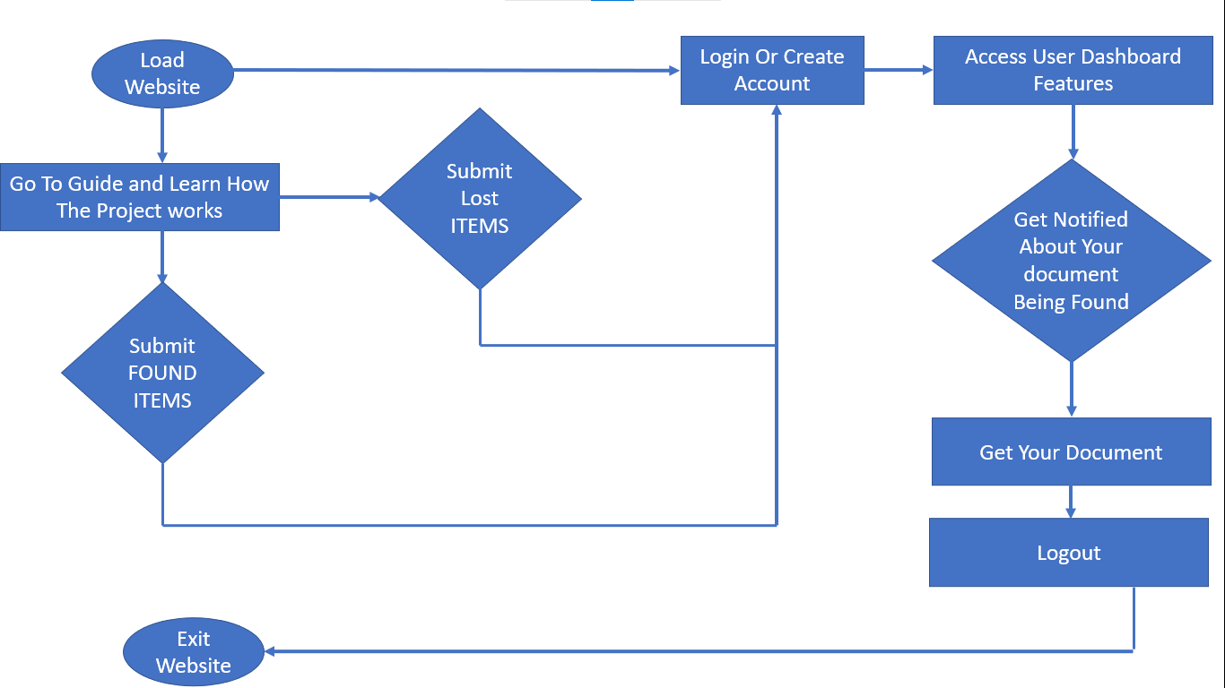

## **ERD**

NOTE: THE ERD DIAGRAM WAS ATTACHED AT THE LAST PAGE; IT IS SO LONG IT CAN NOT FIT HERE.

## **IMPLEMENTATION**

In this section, we delve into the intricacies of our platform's Implmentations how our platform works both on the front end and on the backend.

### **Technologies used**

MyLostFind.Com leverages a robust stack of technologies, including PHP for server-side scripting and MySQL for database management. HTML, CSS, and JavaScript are employed to create an interactive and responsive user interface. We also utilize Google Maps for location-based services, ensuring a seamless and feature-rich experience for our users.

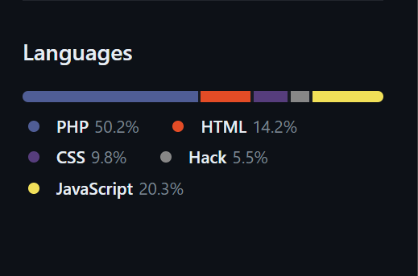

[(GitHub Image showing technologies used and percentage of their code occupation)](https://github.com/Derrick-Nuby/My-Lost-Find/tree/fa97bf8dff3ffa0c2c17f7fad7f2f481341c7265#:~:text=%2B%2018%20deployments-,Languages,-HTML)

### **better code**

Our commitment to providing a reliable and efficient platform goes beyond functionality; it extends to the code itself. We prioritize clean and well-documented code, adhering to best practices and coding standards. This not only enhances the platform's stability but also simplifies future maintenance and scalability.

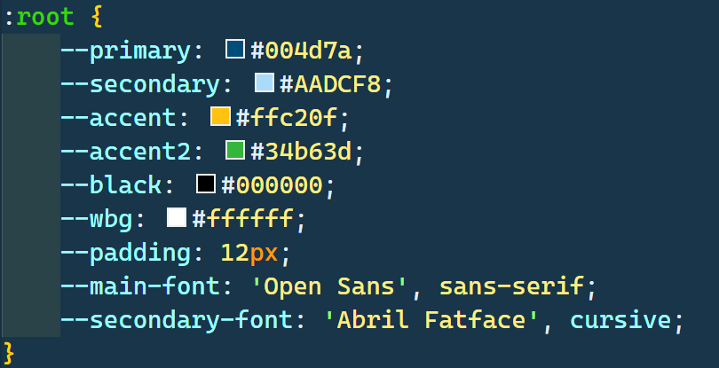

[(Code Image Showing How We Used Css variables for better code)](https://github.com/Derrick-Nuby/My-Lost-Find/blob/fa97bf8dff3ffa0c2c17f7fad7f2f481341c7265/styles.css)

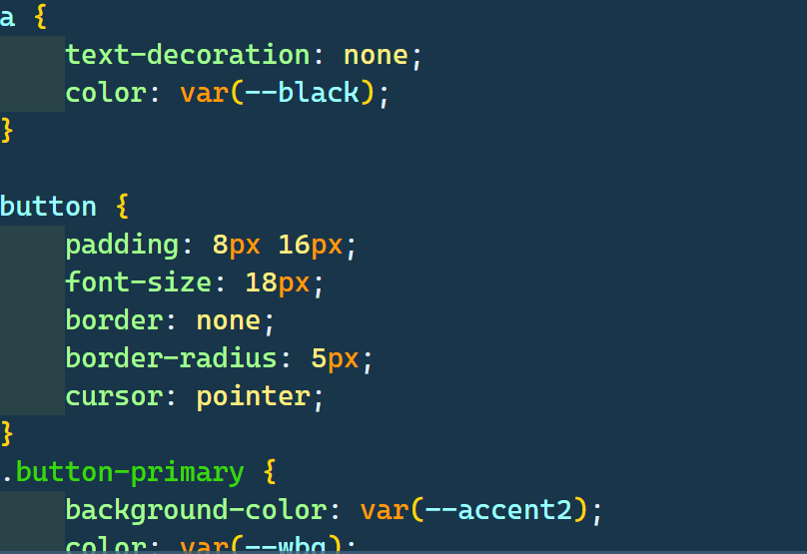

[(Code Image Showing How We Used global variables to achieve better code)](https://github.com/Derrick-Nuby/My-Lost-Find/blob/fa97bf8dff3ffa0c2c17f7fad7f2f481341c7265/styles.css)

Those images above are some example that we used better code. The full code can be found in the github repo below.

### **Responsiveness & Design**

MyLostFind.Com boasts a responsive design that adapts seamlessly to various devices and screen sizes, ensuring accessibility for users on mobile phones, tablets, and desktop computers. The design is intuitive and user-friendly, prioritizing ease of navigation and a visually appealing interface.

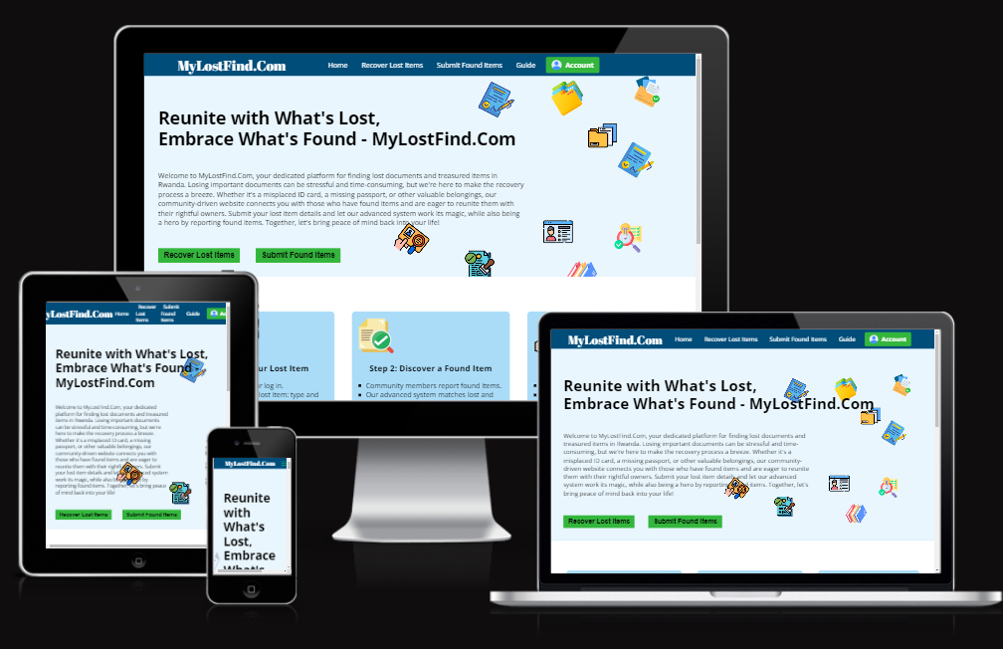

(Image showing MyLostFind On different devices representing responsivenes)

### **Homepage**

The homepage serves as the gateway to our platform, featuring a clear well organised menu which facilitates website navigation and easy finding resources, It is also worth noting that the menu is responvie and can slide from the top as illustrated in the images below.

The user also get to see a rich and relaxing hero section with an about that explains what we do with two call to actions that helps them to choose if they want to Recover Lost Items or Submit Found Items.

The HomePage also features the step by step explained procedure from loosing your document submitting your request and getting it delivered to you with call to actions, this helps our users understand pretty much everything by just visiting our website homepage.

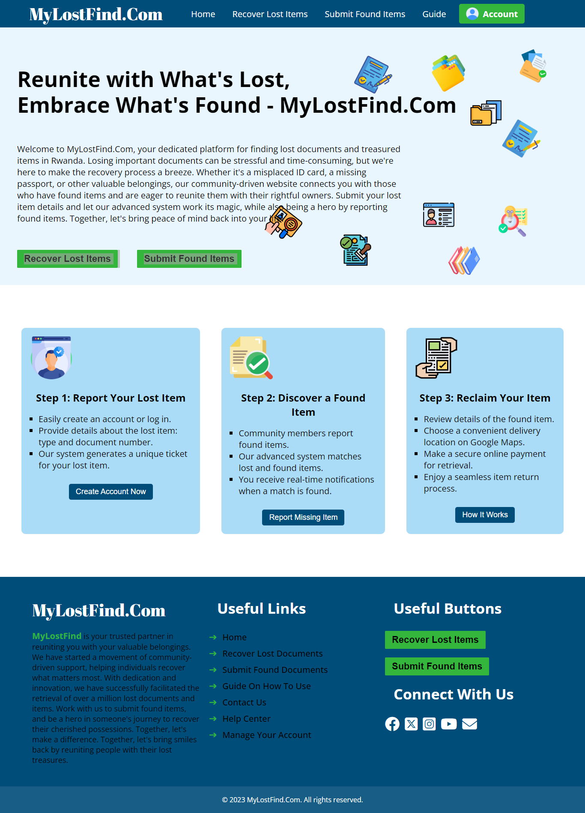

(Image Showing the whole screenshot of our homepage with menu footer and herosection)

Our footer encapsulates the essence of MyLostFind.Com's mission and functionality. the footer provides useful links to key sections of our platform and serves as a reminder of our copyright, demonstrating our commitment to providing a secure and trusted lost item recovery solution. The footer Also gives our users a chance to follow us on social medias to receive platform support and updates.

### **About us Page**

In this section, users can learn more about our project's mission, vision, and the team behind it. We provide insights into our commitment to community engagement and user-centered design, fostering trust and transparency.

### **Guide & Faq Page**

Our comprehensive guide equips users with the knowledge they need to navigate the platform effectively. It offers step-by-step instructions, tips, and, ensuring a smooth user experience.

Guide page below:

Our Faq section Lists the most asked questions and their answers which help users know a lot about our platform.



(Image Showing the whole screenshot of our guide page)



(Image Showing the whole screenshot of our guide page)

### **Report Lost Items Page**

The "Report Lost Items" page is a pivotal component of MyLostFind.Com, designed to simplify and expedite the process of reporting lost items and initiating their recovery. At the heart of this page is a user-friendly form that collects crucial information, ensuring a seamless experience for individuals seeking to retrieve their belongings.

* **Item Type:** Here, users can specify the type of item they've lost. It could be a document, passport, driver's license, or any other valuable possession.
* **Select Document Type:** This dropdown menu allows users to choose the specific type of document they've lost, ensuring that the reporting process is tailored to the nature of the item.
* **Document Number:** Users are prompted to enter the unique identification number of the lost document. This critical detail is vital for matching lost items with found ones accurately.
* **Location Lost:** To assist in the search process, users provide information about where the item was lost. This could be a specific location, such as an address or a general description of the area.
* **Date Lost:** Users are asked to input the date on which the item was lost. This timestamp helps in tracking the item and matching it with found items based on the date of loss.
* **Description:** In this section, users can provide additional details about the lost item. This might include any distinguishing features, circumstances surrounding the loss, or any other relevant information that can aid in its recovery.

A notable point to emphasize is that to access all the functionalities of this page, users are required to log in or create an account. This login requirement ensures the security and privacy of the lost item reporting process.

Overall, the "Recover Lost Items" page is meticulously designed to empower users with a straightforward and comprehensive reporting mechanism. By gathering these essential details, we streamline the search and retrieval process, increasing the likelihood of reuniting individuals with their lost possessions.

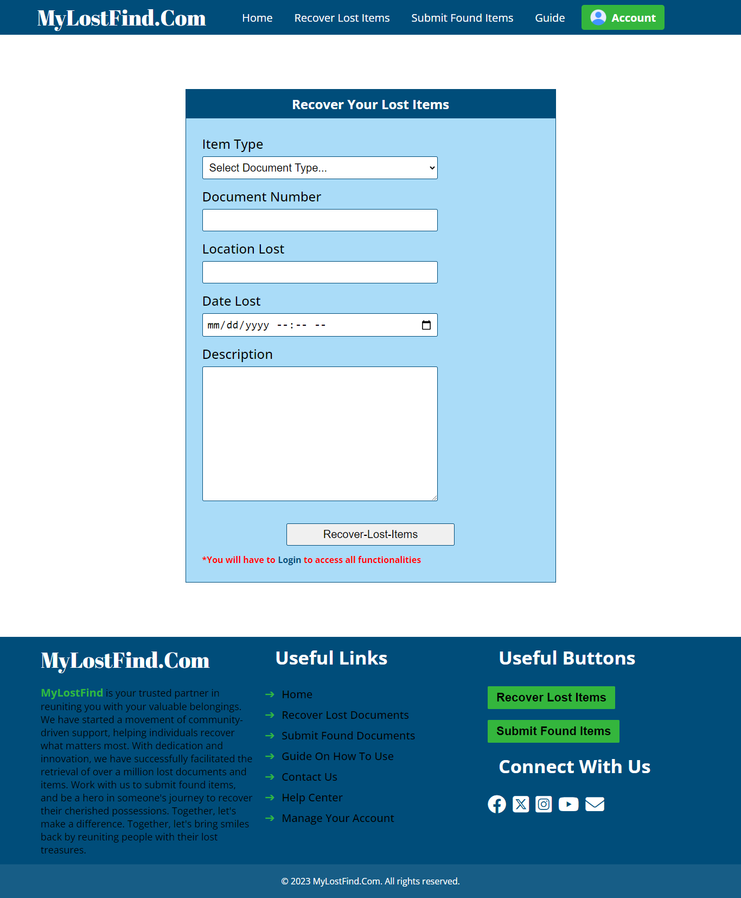

(Image Showing the whole screenshot of report Lost Items Page)

### **Submit Lost Items**

The "Submit Found Items" page is the platform's central hub for individuals who have found lost items. This page empowers them to play a vital role in reuniting these items with their rightful owners. At its core is a straightforward and user-friendly form that collects essential information to facilitate the return process.

* **Item Type:** Users are prompted to specify the type of item they've found. It could be a document, passport, driver's license, or any other valuable item.
* **Select Document Type:** This dropdown menu allows users to choose the specific type of document they've found. This ensures that the submission process aligns with the nature of the discovered item.
* **Document Number:** Users are asked to enter the unique identification number of the found document. This detail is crucial for accurately matching found items with lost ones.
* **Location Found:** To assist in the reunification process, users provide information about where they found the item. This could be a specific location, such as an address, or a general description of the area.
* **Date Found:** Users are prompted to input the date on which they found the item. This timestamp is essential for tracking the item and matching it with lost items based on the date of discovery.
* **Description:** In this section, users can provide additional details about the found item. This might include any distinguishing features, the condition of the item when found, or any other relevant information that can aid in its return to the rightful owner.

It's important to note that to access all the functionalities of this page, users are required to log in or create an account. This login requirement ensures the security and privacy of the item submission process, protecting both those who have found items and those who have lost them.

In summary, the "Submit Found Items" page is designed to empower individuals to be heroes in someone else's story by facilitating the return of lost possessions. By collecting these essential details, we streamline the process of matching found items with their rightful owners, making a positive impact on our community.

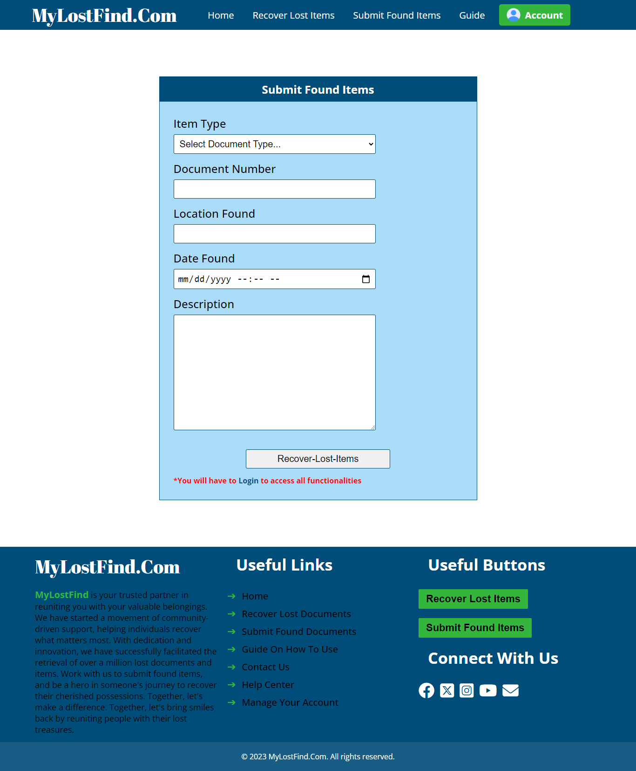

(Image Showing the whole screenshot of submit found item page)

### **Login And Creating Account**

To access the full suite of MyLostFind.Com features, users can create accounts with ease. The login page offers secure authentication, and it provides password checking and can return an error based on the details you have put inside.

The login and create account come in tabs that can be accessed without need to go to other pages, which provides the ease of use we aimed about.

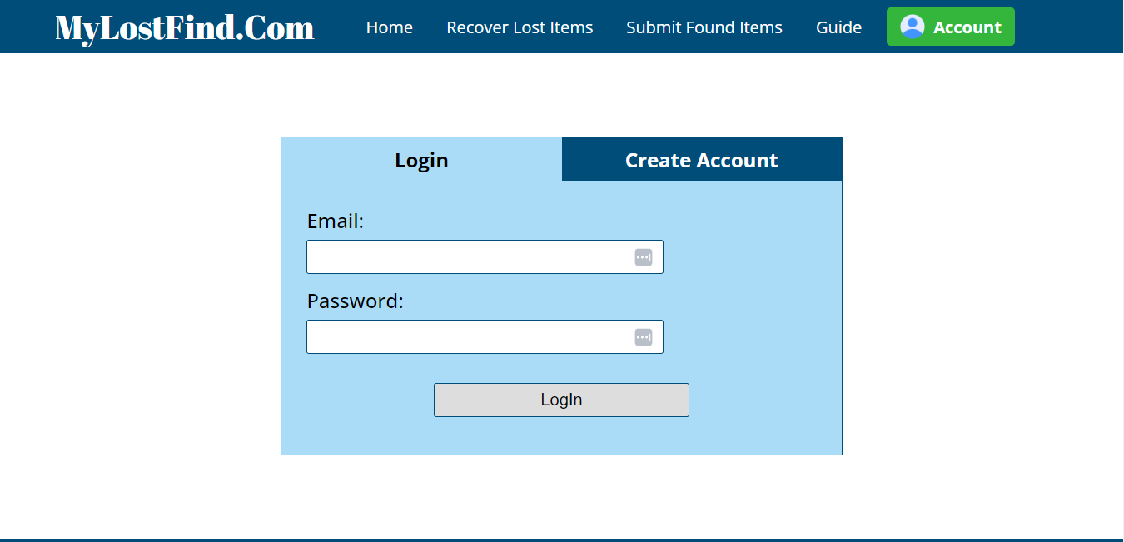

(Image Showing normal login page)

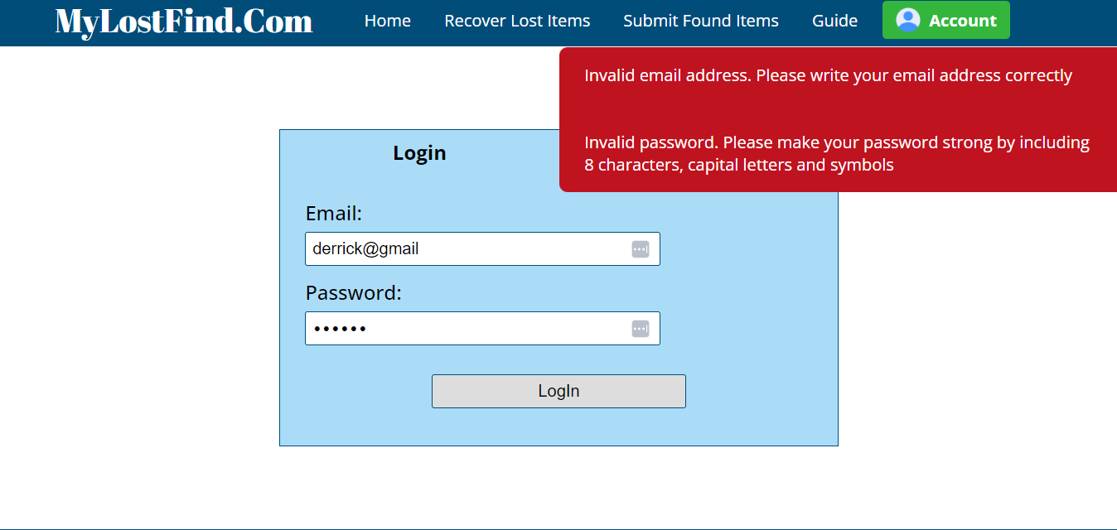

(Image Showing worng user error generation with a right to left slider)

Also account creation process includes verification of identity an password double checker. Here user include most details of themselves for us to make sure they are real humans.

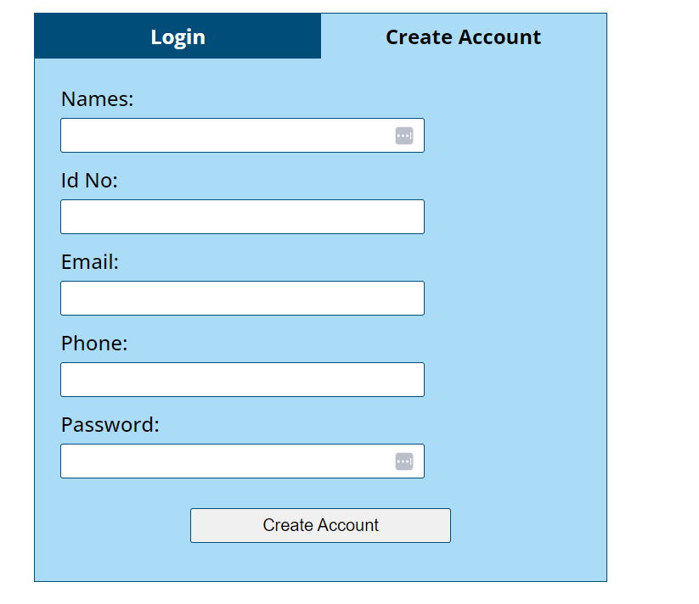

(Image Showing create account page)

### **User Dasboard**

Our user dashboard is thoughtfully designed with intelligence and user-friendliness in mind, ensuring that users have easy access to the features they need to manage their lost and found items effectively.

**Intelligent Design and Toggle Sidebar:** The user dashboard boasts an intelligent design, ensuring that all key functions are easily accessible. Users can also toggle the sidebar for streamlined navigation, allowing them to quickly find what they're looking for.

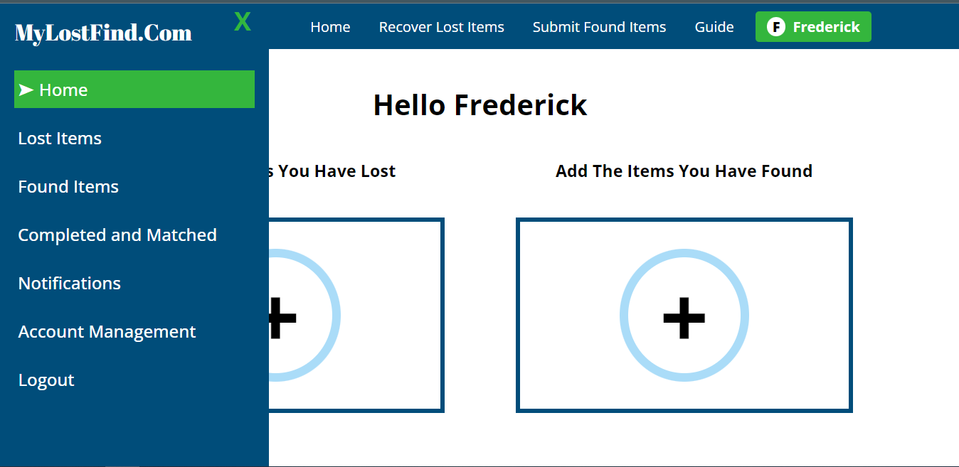

(Image Showing user dashboard Frederick login with sidebar open)

**Homepage:** Upon logging in, users are greeted with a homepage that offers two primary actions. They can swiftly report a lost item or file a report regarding a found item through a well-designed popup. This user-friendly interface simplifies the process of initiating lost item recovery and contributing to the return of found items.



(Image Showing the user homepage with the sidebar buttons with no footer)

**Notifications Page:** Users can conveniently view notifications related to found items or updates on their reported lost items. These real-time notifications keep users informed and engaged in the recovery process. In the user dashboard, there is a dedicated notifications page that informs users of any messages or updates from the admin. Whether it's related to matches or information about their found or reported items, this feature keeps users informed and engaged.

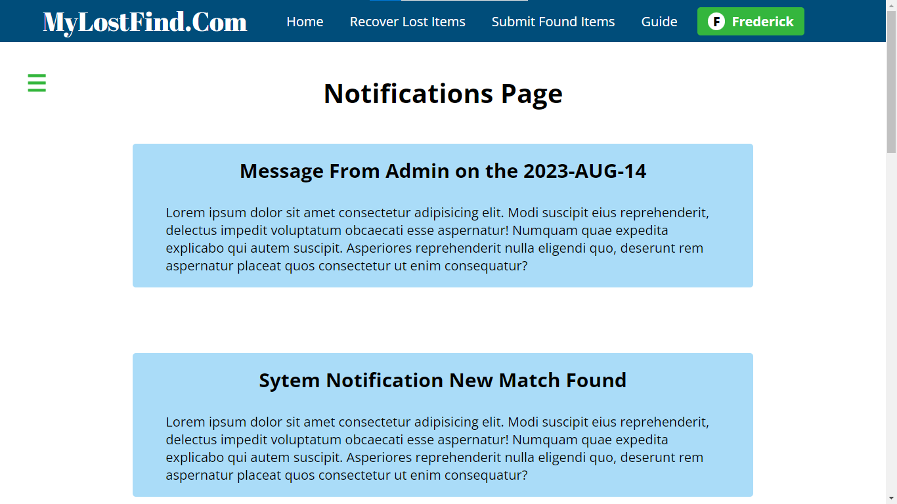

(Snapshot of the first notification for user)

**View Lost Item Submissions Page:** In the user dashboard, there is a dedicated page where users can view all their submitted lost item reports. The information is presented in a table format, with a "More Details" button for each item. Clicking this button provides users with comprehensive information about each lost item, streamlining their oversight of the submission process.

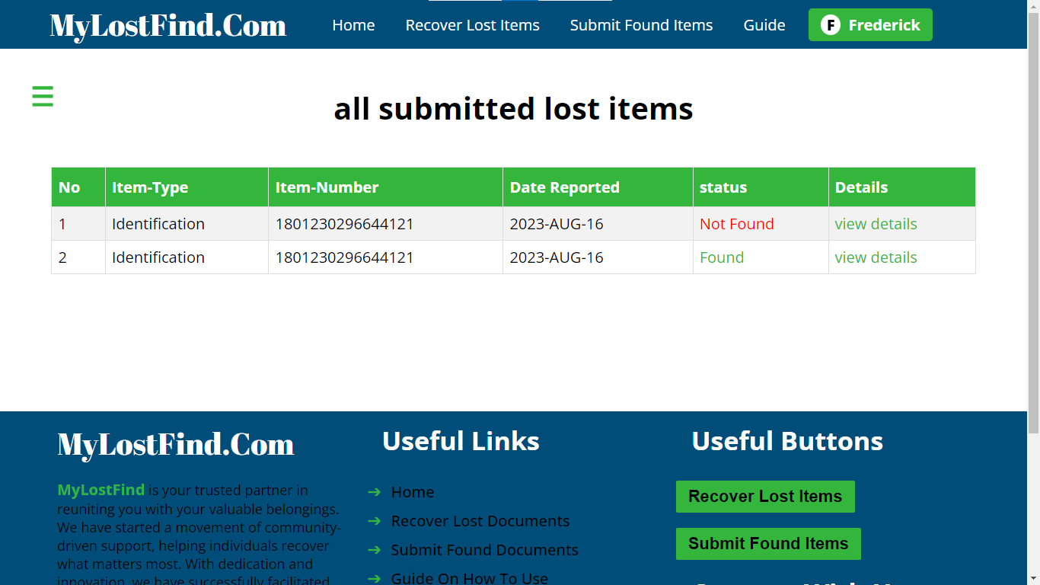

(lost items submiited by a certain user)

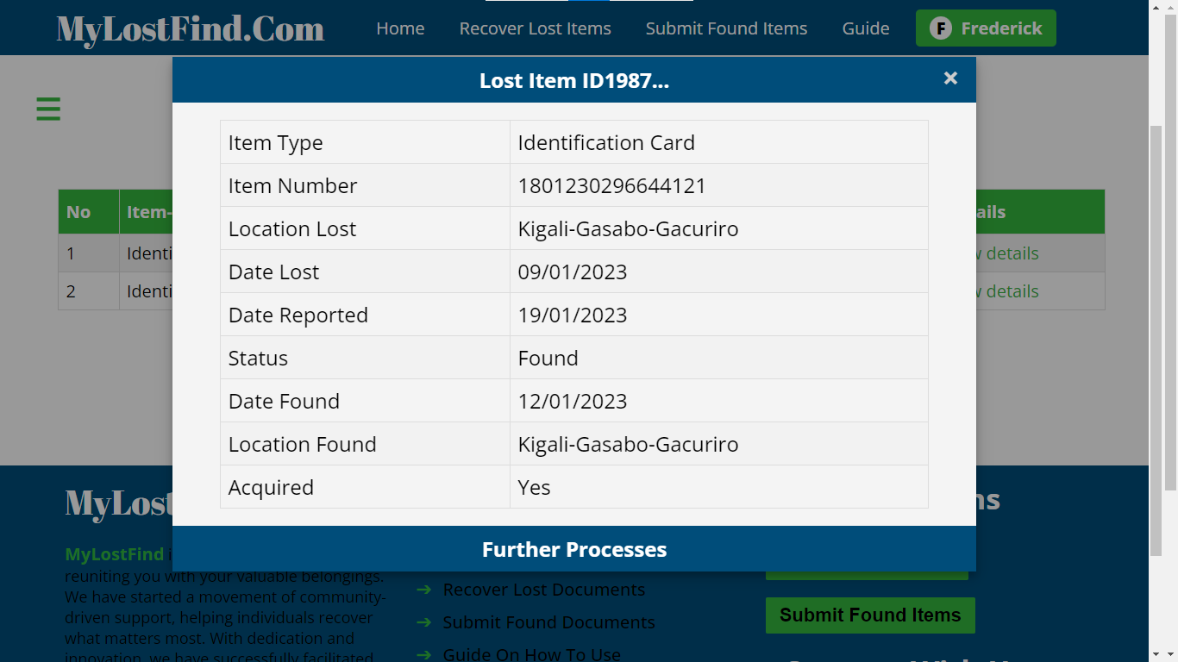

(an example of the view details is clicked to view more details of each item)

**View Found Item Submissions:** Similarly, users can access a page that displays all their submitted found item reports in a tabular format. The "More Details" button allows users to delve deeper into the specifics of each found item they've reported, ensuring transparency and efficient management. Also a popup appears when you click the view details button.

**View Matched and Successful Submissions:** A crucial aspect of the user dashboard is the ability to view all matched and successful submissions. This page provides users with insights into the items that have been successfully reunited with their owners. The "More Details" button offers comprehensive information about each successful match, allowing users to celebrate the positive outcomes.

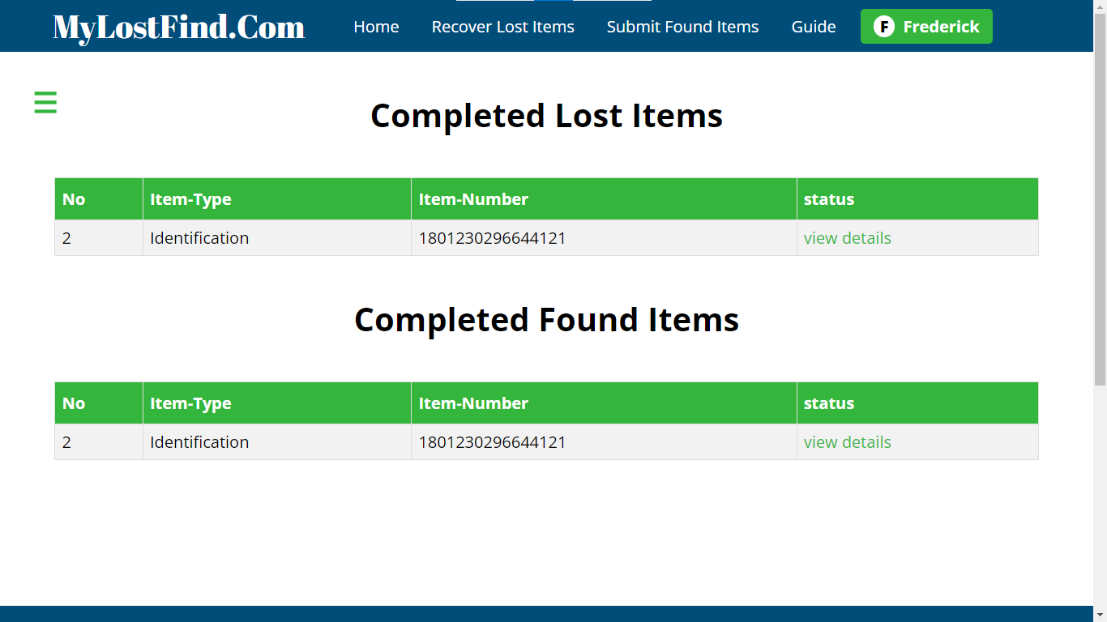

(a page showing matched submission)

**Account Management:** Users have the autonomy to manage their accounts efficiently. They can change their password and update their phone number as needed, ensuring that their account information is up to date. However, the user ID remains constant, as it is a critical component of their identification within the system. User can not edit their id no and account creation date

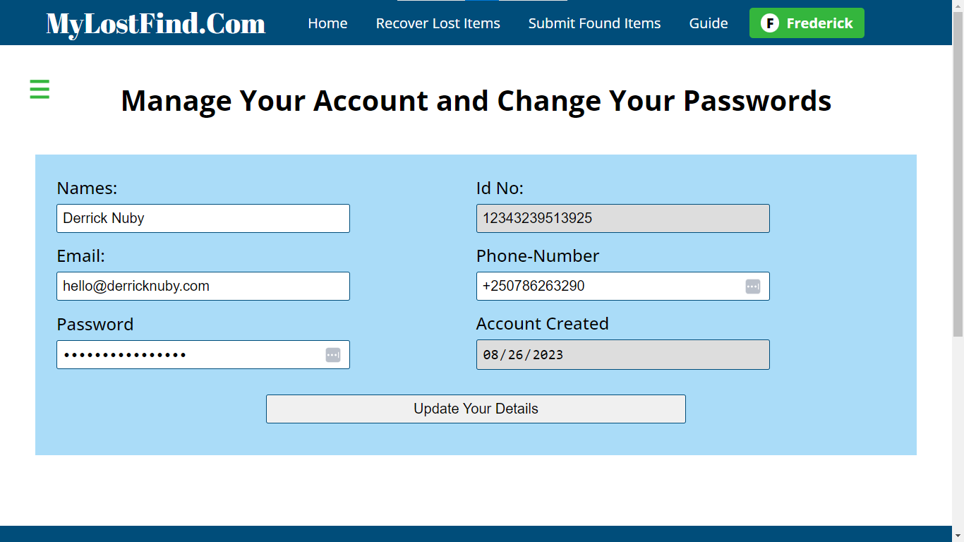

(Image showing what user can edit)

There is also a logout button and the buuton up top show who is logged in. the user log for Frederick is. [frederick@exampl.com](mailto:frederick@exampl.com) and password is MySecrue123@#

The user dashboard is a central hub for individuals seeking to recover lost items or contribute to the return of found items. With its intelligent design, easy navigation, and a comprehensive set of features, it empowers users to take control of their lost item recovery journey while fostering a sense of community support.

### **Admin Dashboard**

Our admin dashboard provides administrators with a centralized view of user submissions, lost and found items, and ticket management. It streamlines administrative tasks, making it efficient to oversee and support the lost item recovery process.

**Home:** The admin's central hub, where they can access quick notifications and a summary of system actions. This page provides an overview of platform activities and helps the admin stay informed about new matches, contacted users, submitted items, accounts, and system status.

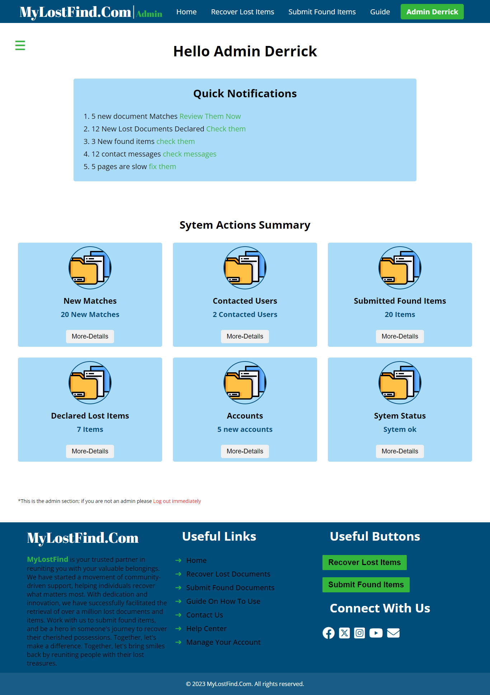

(Image showing admin Homepage)

**Submitted Lost Items Page:** This page allows the admin to view and manage all submitted lost item reports. Admins can review details of lost items, match them with found items, and assist users in their efforts to recover their belongings. It's a pivotal page for reuniting users with their lost possessions.

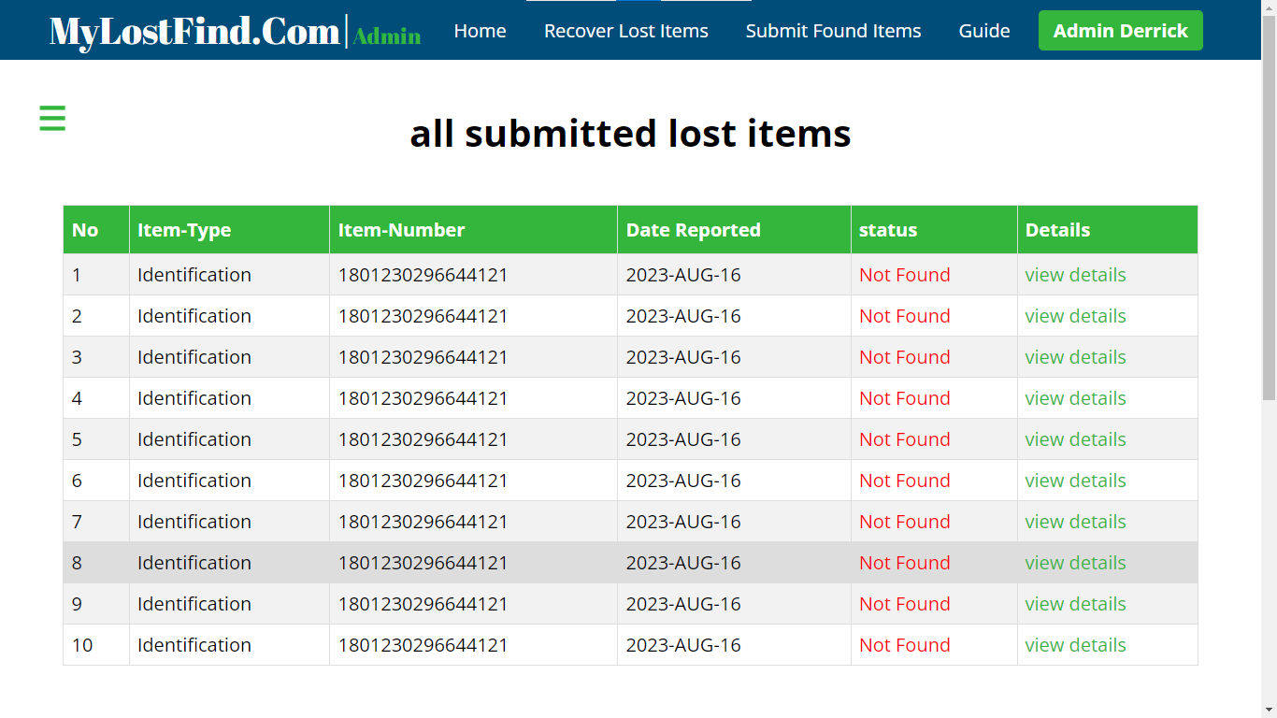

(Image Showingadmin dashboard where he can view all submitted lost documents)

**Submitted Found Items:** Here, the admin can review and manage all submitted found item reports. Admins can verify the details of found items, match them with lost items, and facilitate the return process. This page plays a crucial role in making found items available for recovery.

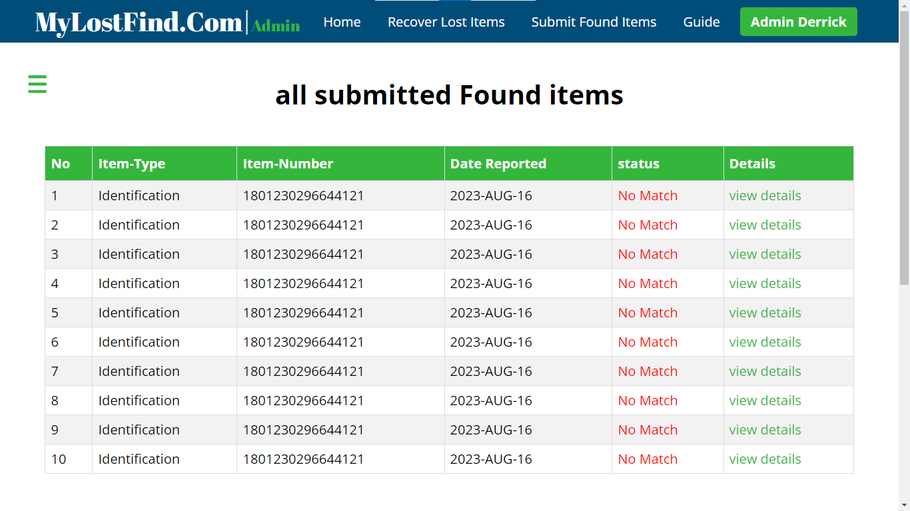

(Image Showingadmin dashboard where he can view all submitted found documents)

**Contacted People:** Admins can access this page to view and respond to messages from users who have reached out for assistance or clarification. Effective communication is vital in building trust and ensuring users have a positive experience.

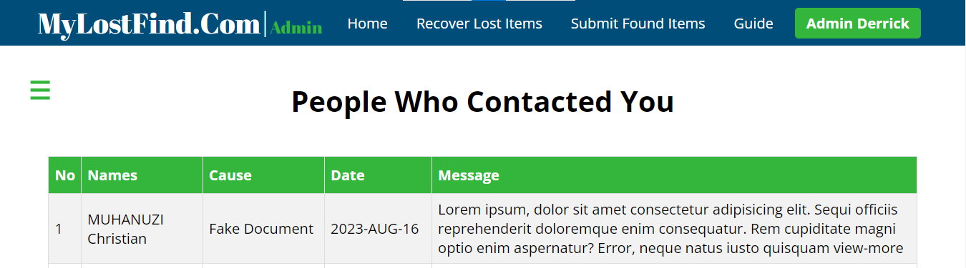

(Image Showingadmin dashboard where he can view all those who contacted him throught the contact form)

**Accounts & Users:** This page allows the admin to manage user accounts efficiently. Admins can review new account registrations, update user information, and ensure the platform's user base remains secure and trustworthy.

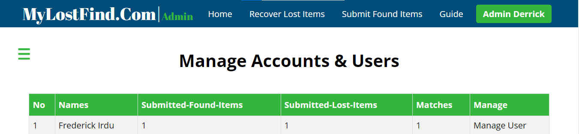

(Image Showingadmin dashboard where he canmanage users)

**System Status:** Admins can monitor the system's health and performance on this page. It provides insights into the system's operational status, ensuring that it operates smoothly and efficiently.

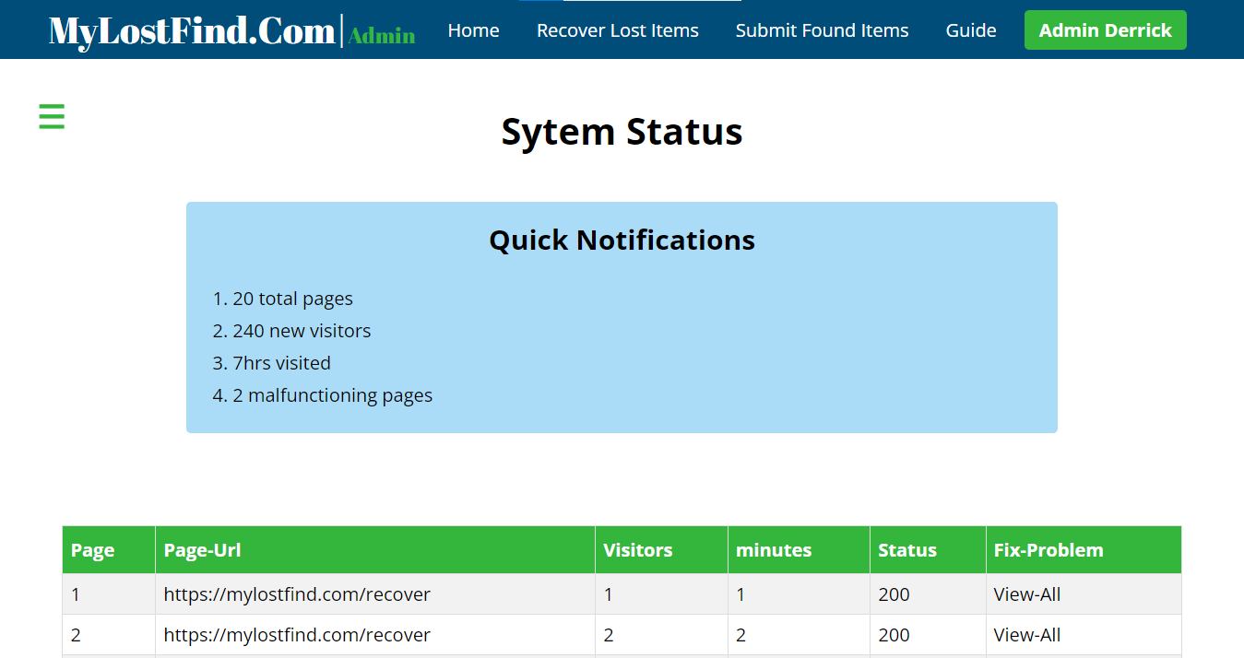

(Image Showingadmin dashboard where he can view System status)

**Logout:** The logout page allows the admin to securely log out of their admin account. This is essential for maintaining the security and privacy of the admin's session.

These pages collectively empower the admin to oversee and manage the platform effectively, fostering a community-driven environment for lost item recovery.

## **CONCLUSION**

In conclusion, MyLostFind.Com represents not just a project but a transformative solution to a common problem that affects countless individuals. Our journey has been guided by a commitment to simplifying the process of recovering lost documents and items, reducing the associated challenges, and fostering a sense of community support. As we stand on the cusp of realizing our vision, we are driven by the belief that through user-centered design, cutting-edge technology, and a commitment to accessibility, we can make a meaningful difference in the lives of those who have experienced the frustration of losing something valuable. MyLostFind.Com is not merely a platform; it's a testament to the power of innovation and collaboration in solving real-world problems. We look forward to a future where lost items find their way back home, where communities unite to help one another, and where the journey from lost to found becomes a smoother and more reassuring one for all.

## **REFERENCES & OTHERS**

### Git-Hub Link

<https://github.com/Derrick-Nuby/My-Lost-Find>

### Other Related Links and external sources

1. [Accounting Treatment Of Stolen Assets & Insurance Compensation | Q&A | Simplified (accounting-simplified.com)](https://accounting-simplified.com/financial/articles/stolen-lost-assets-accounting-treatment/)
2. [Impaired Asset Definition, Measurement, & Examples | NetSuite](https://www.netsuite.com/portal/resource/articles/accounting/impaired-asset.shtml)
3. [LandAdministrationReformsinRwanda.pdf (worldbank.org)](https://thedocs.worldbank.org/en/doc/439051611674305609-0090022021/original/LandAdministrationReformsinRwanda.pdf)
4. [How to Apply for a Land Document Replacement : IremboGov](https://support.irembo.gov.rw/en/support/solutions/articles/47001217949-how-to-apply-for-a-land-document-replacement)
5. [How to Apply for a National ID Replacement : IremboGov](https://support.irembo.gov.rw/en/support/solutions/articles/47001191857-how-to-apply-for-a-national-id-replacement)
6. [SIM Registration - MTN Rwanda](https://www.mtn.co.rw/sim-registration/)

### **Abbreviations**